Introduction to Machine Learning in Production

Week-1

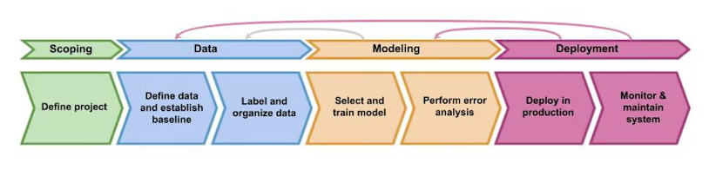

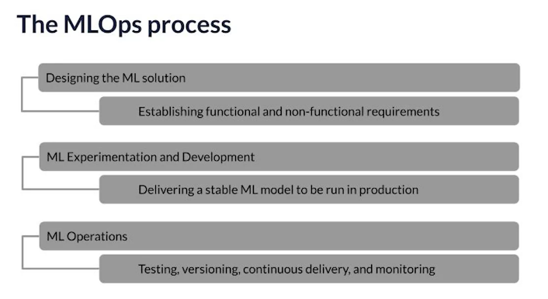

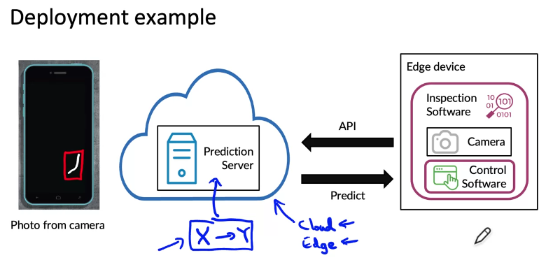



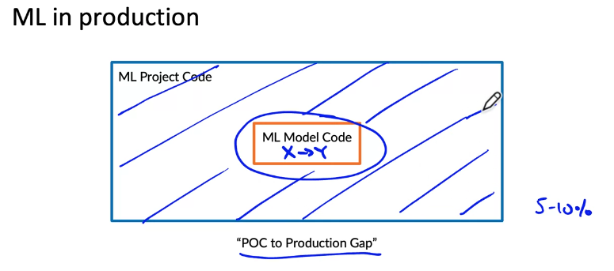

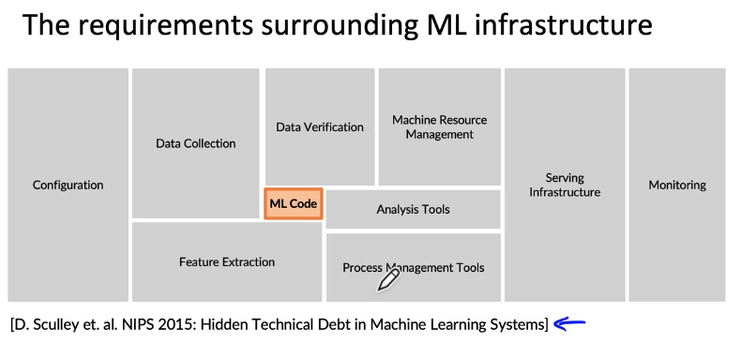

Steps of an ML Project

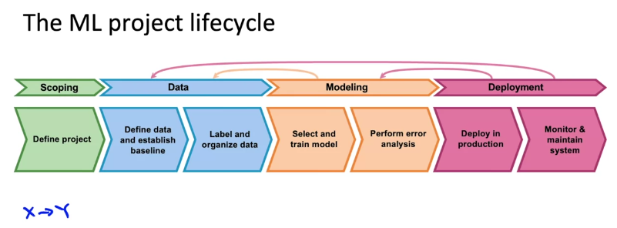

Case study: speech recognition

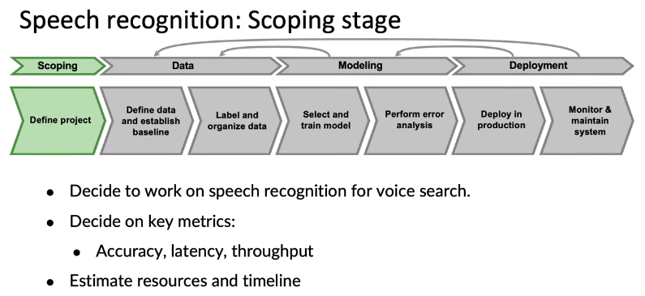

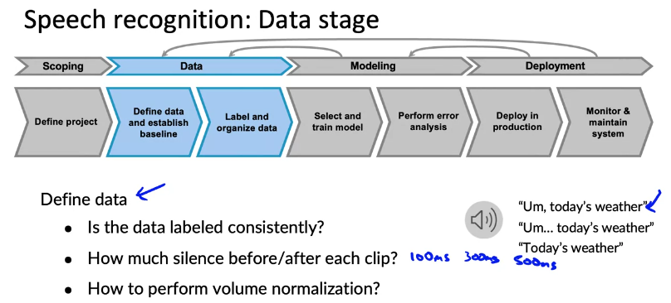

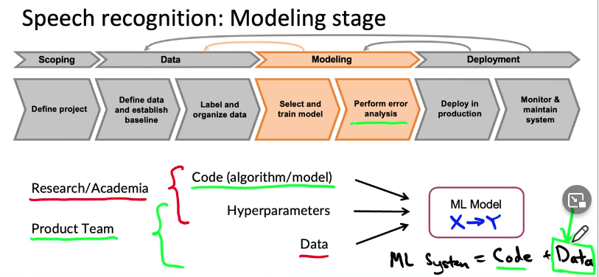
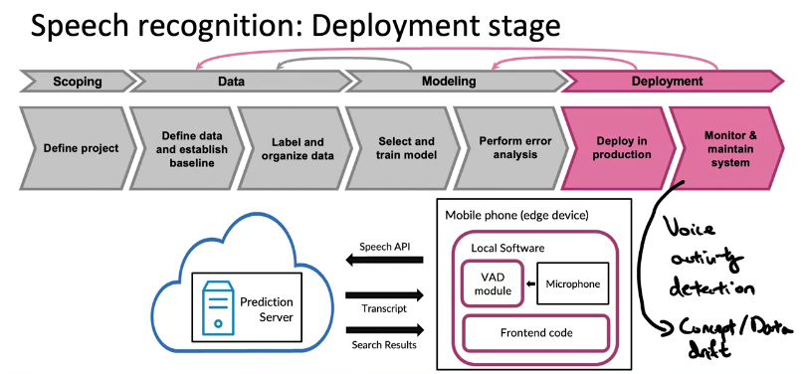

Course outline

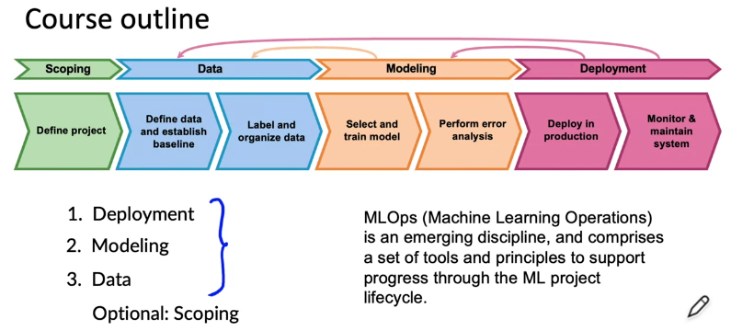

Key challenges

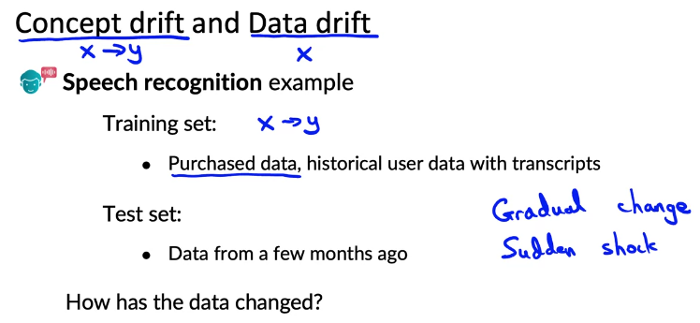

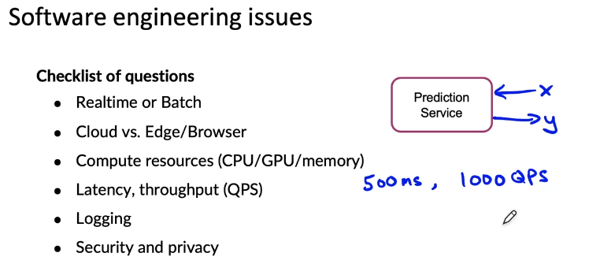

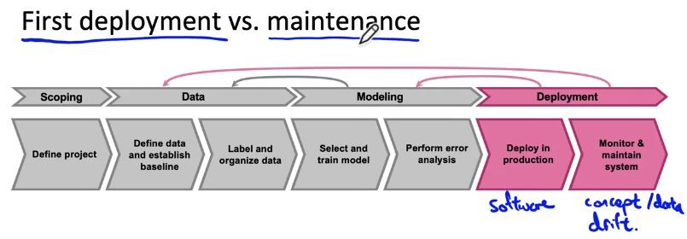

Deployment patterns
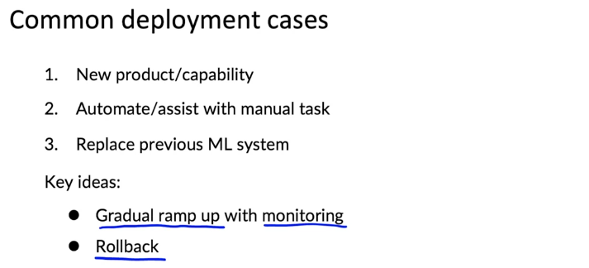

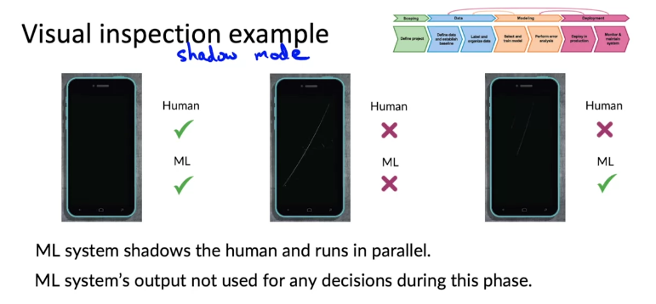

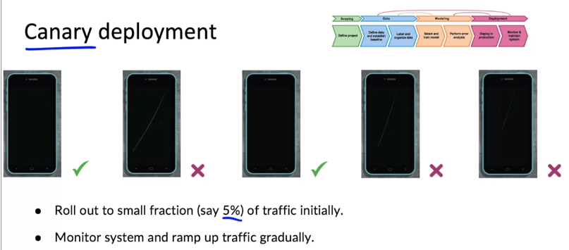

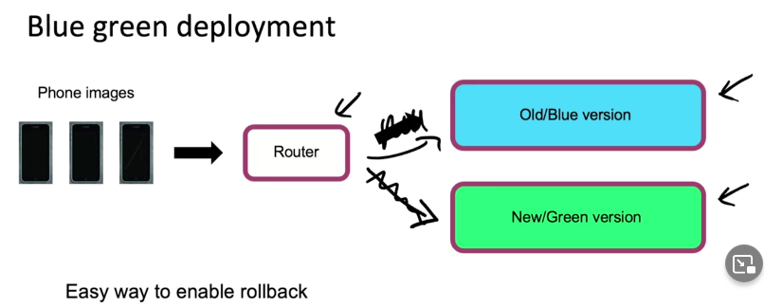
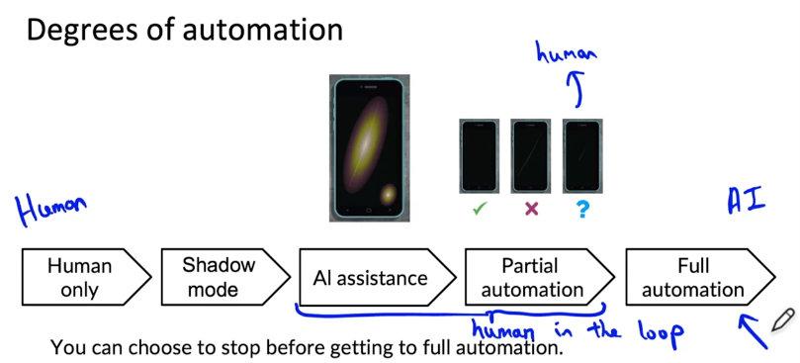

Monitoring

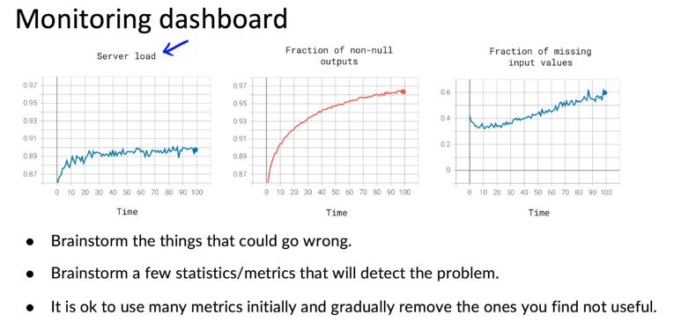

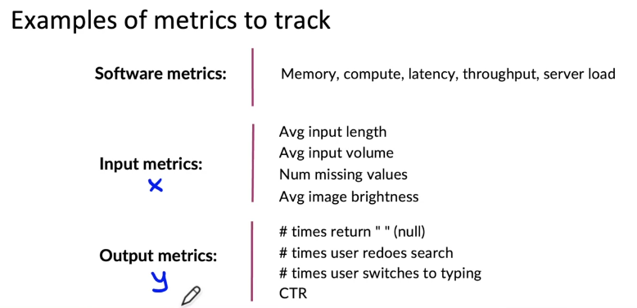

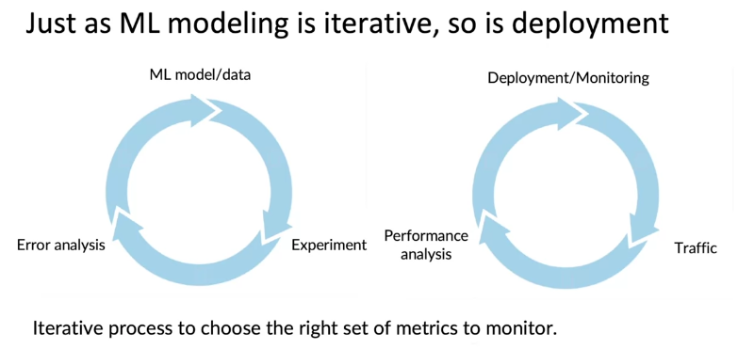

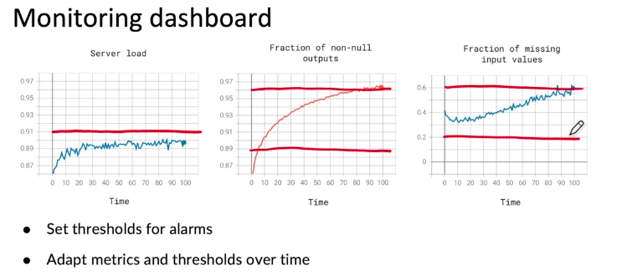

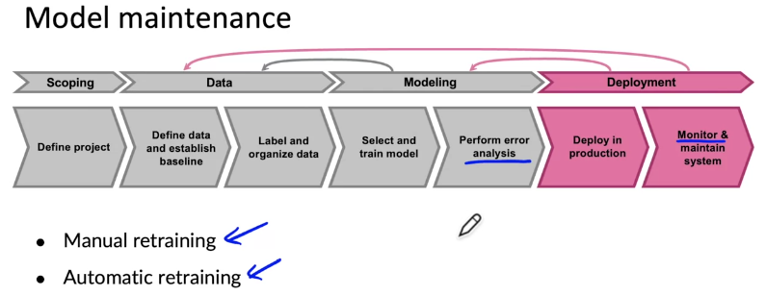

Pipeline monitoring

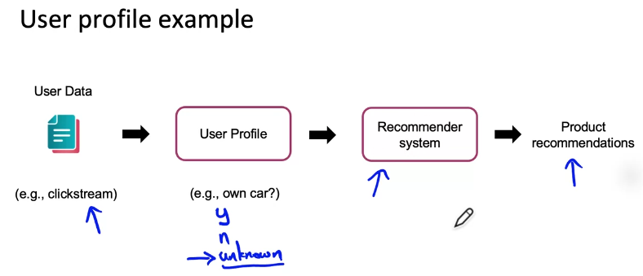

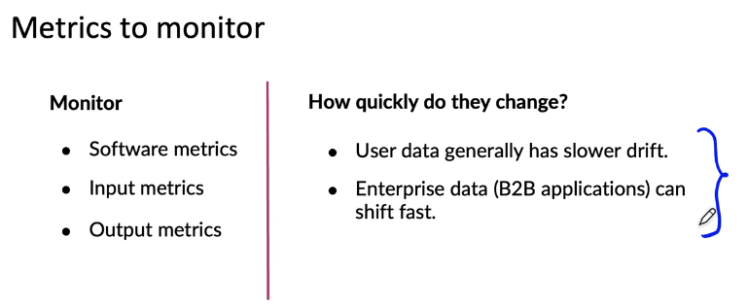

Shadow Model
“Shadow Mode” or “Dark Launch” as Google calls it is a technique where production traffic and data is run through a newly deployed version of a service or machine learning model, without that service or model actually returning the response or prediction to customers/other systems. Instead, the old version of the service or model continues to serve responses or predictions, and the new version’s results are merely captured and stored for analysis.

Red Green Deployment

Blue Green Deployment
Blue green deployment is an application release model that gradually transfers user traffic from a previous version of an app or microservice to a nearly identical new release—both of which are running in production.

Canary Deployment
A canary deployment is a deployment strategy that releases an application or service incrementally to a subset of users. All infrastructure in a target environment is updated in small phases (e.g: 2%, 25%, 75%, 100%). A canary release is the lowest risk-prone, compared to all other deployment strategies, because of this control.

Concept Drift
In predictive analytics and machine learning, the concept drift means that the statistical properties of the target variable, which the model is trying to predict, change over time in unforeseen ways. This causes problems because the predictions become less accurate as time passes.
The term concept refers to the quantity to be predicted. More generally, it can also refer to other phenomena of interest besides the target concept, such as an input, but, in the context of concept drift, the term commonly refers to the target variable.

Data Drift
Data drift is unexpected and undocumented changes to data structure, semantics, and infrastructure that is a result of modern data architectures. Data drift breaks processes and corrupts data, but can also reveal new opportunities for data use.

Week-2

Modeling overview
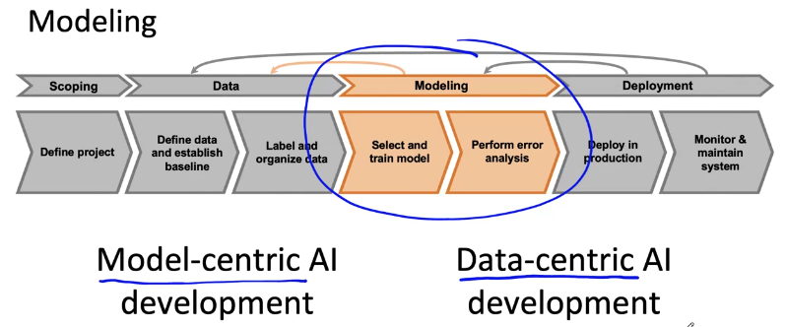

Key challenges


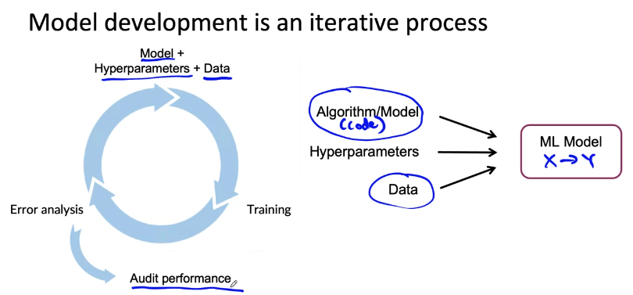
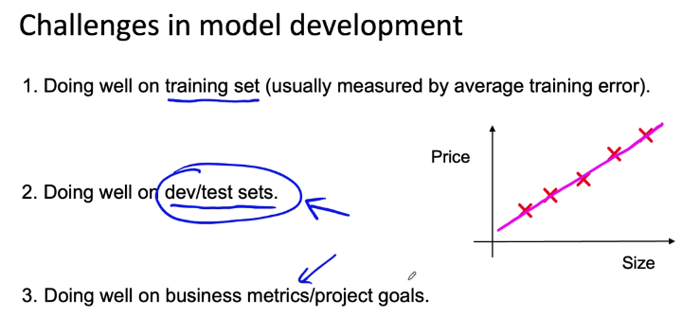

Why low average error isn't good enough

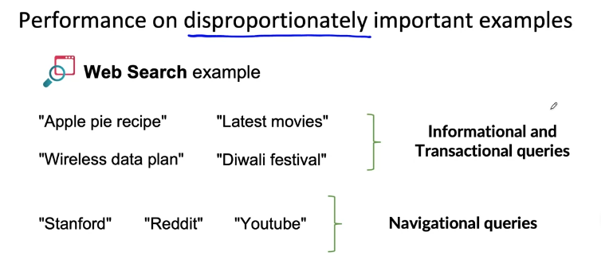

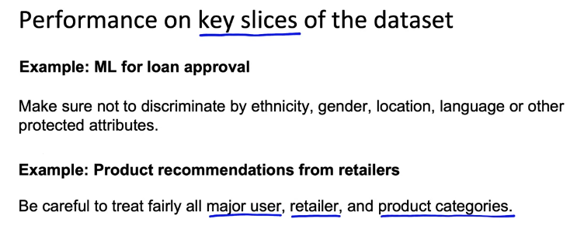
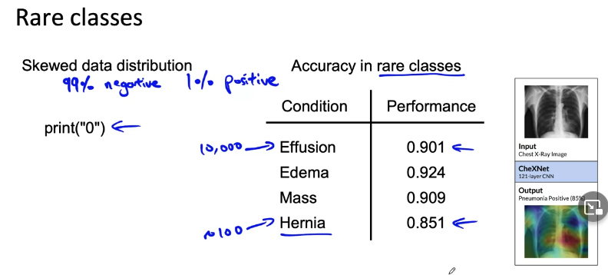

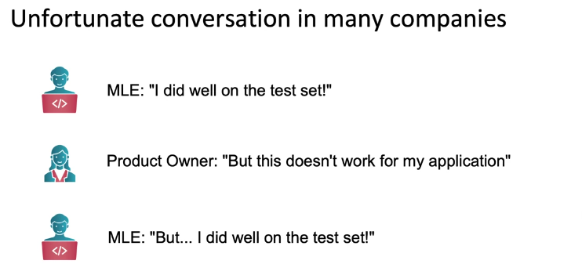

Establish a baseline

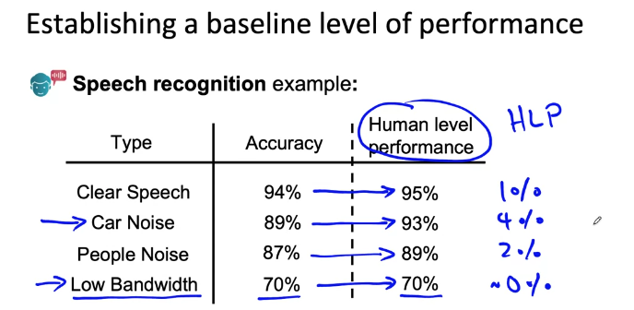

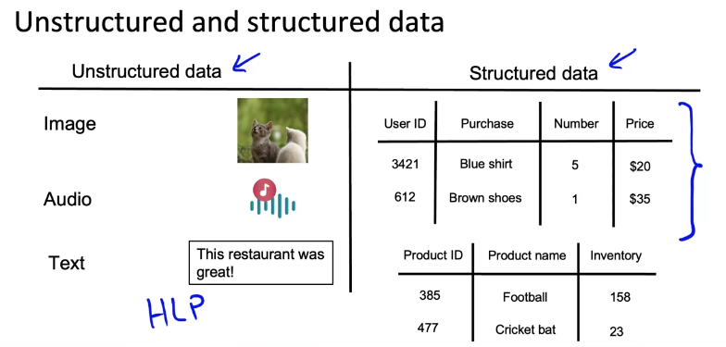

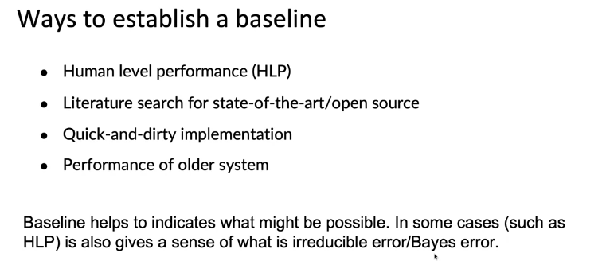

Tips for getting started

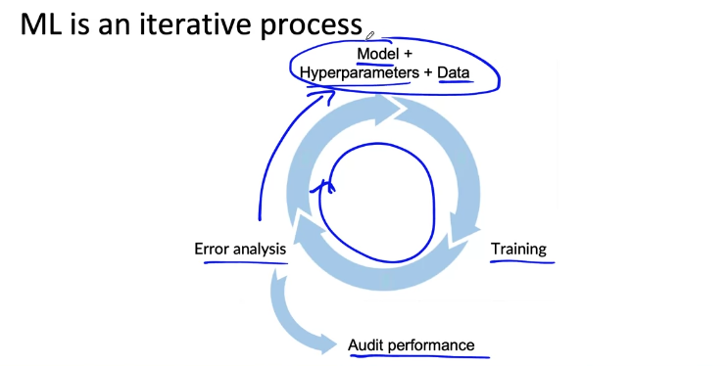

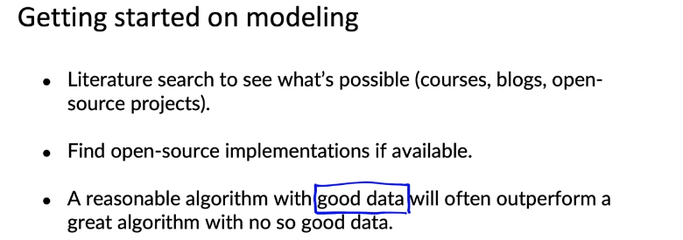

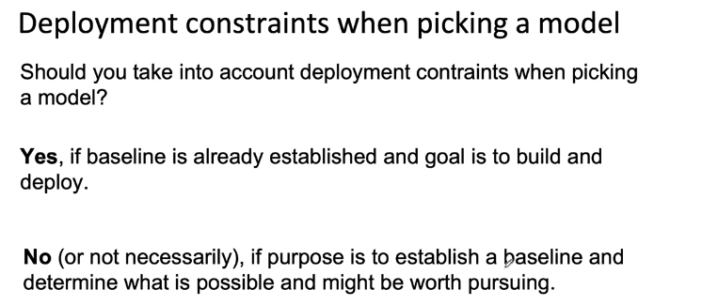

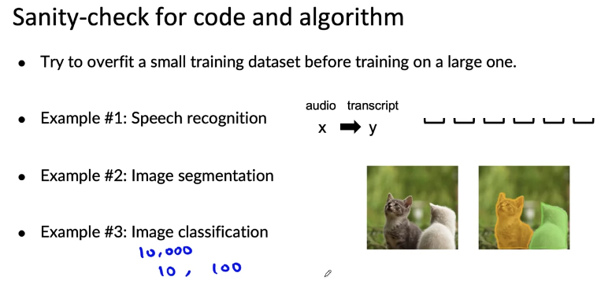

Error analysis example

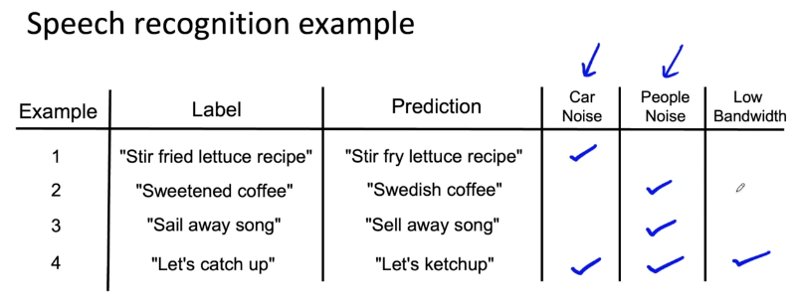

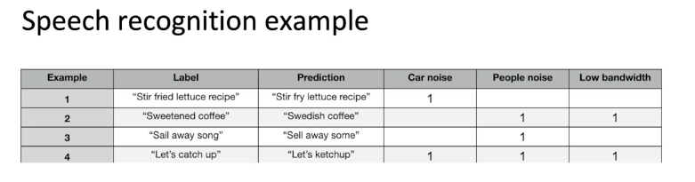

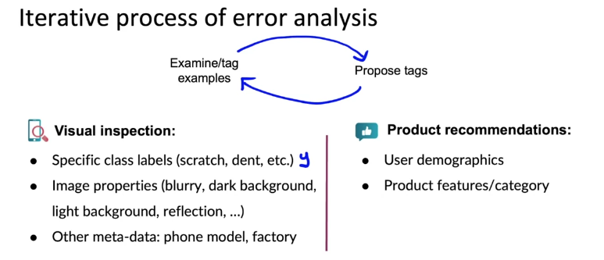

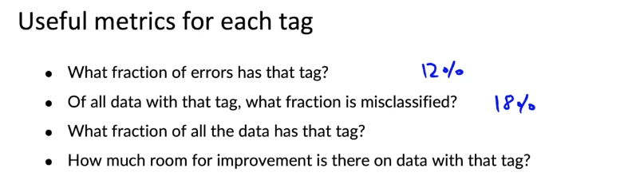

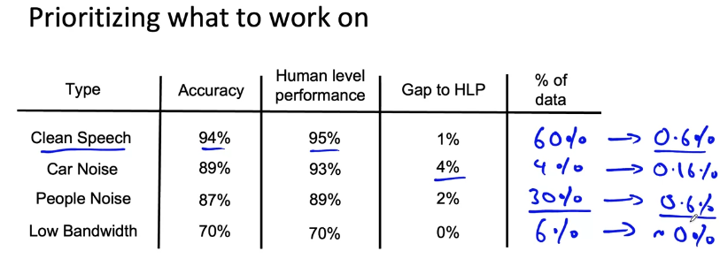

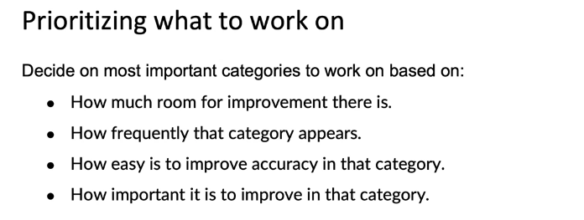

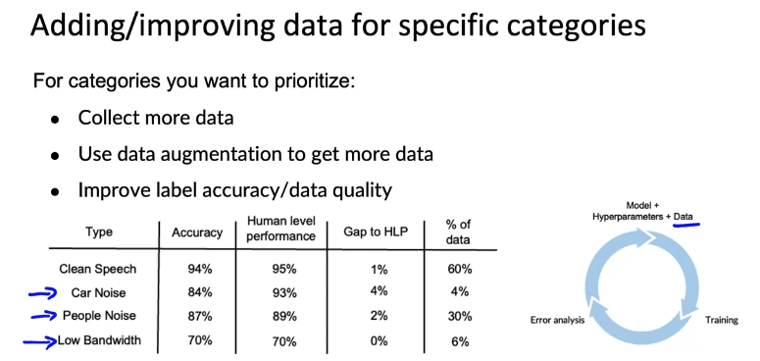

Skewed datasets

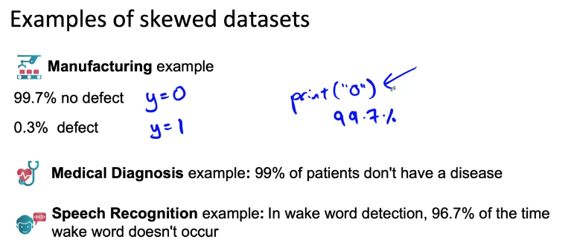

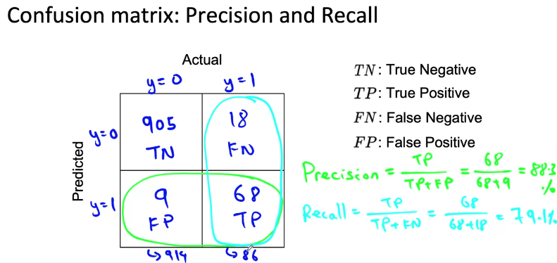

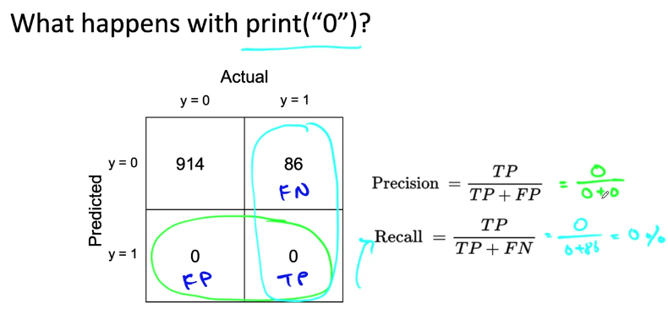

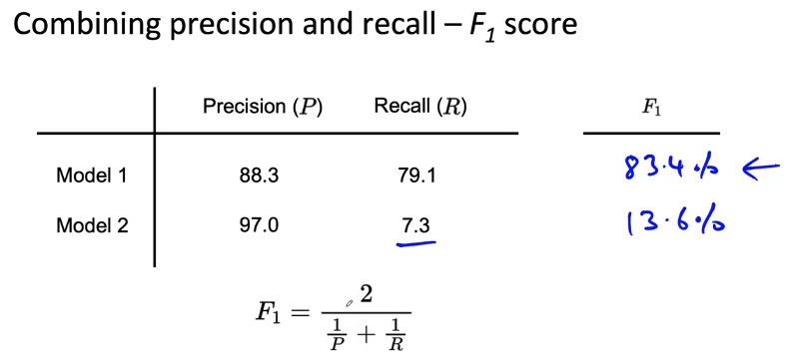

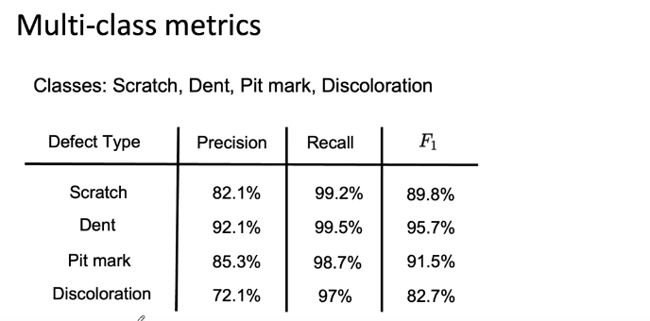

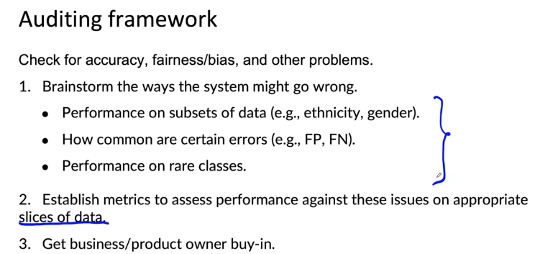
Performance auditing

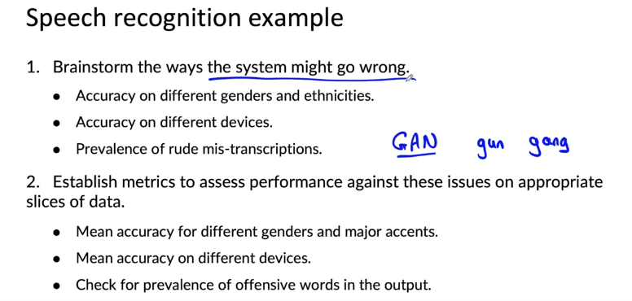

Data-centric AI development

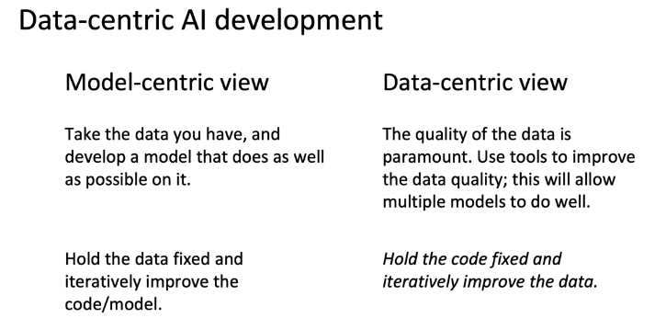

A useful picture of data augmentation

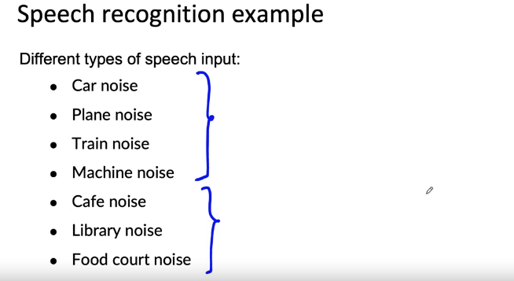

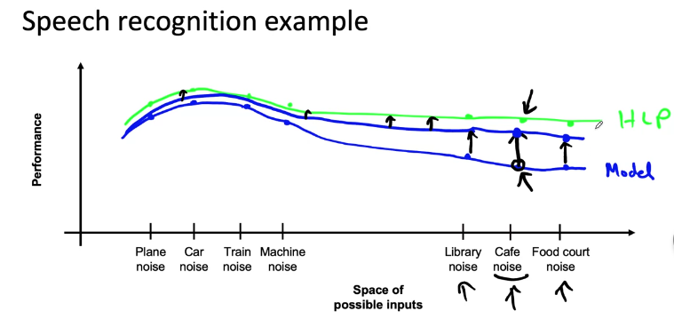

Data augmentation

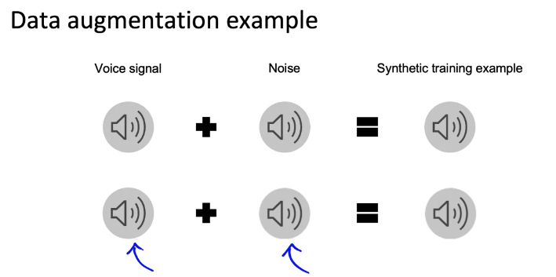

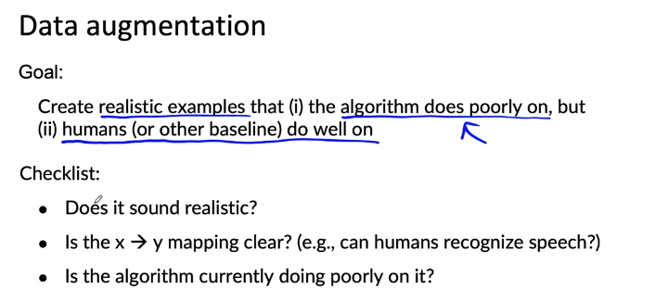

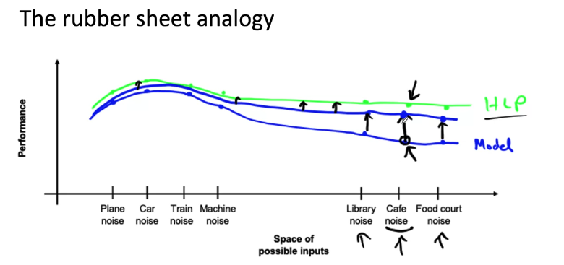

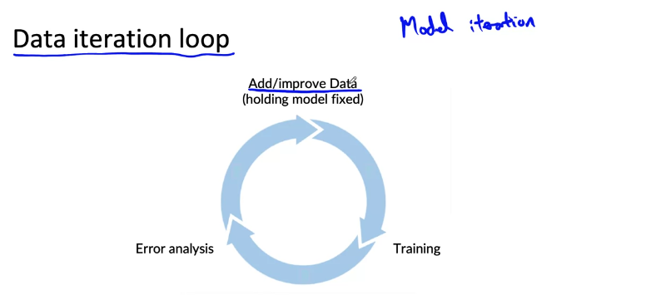

Can adding data hurt?

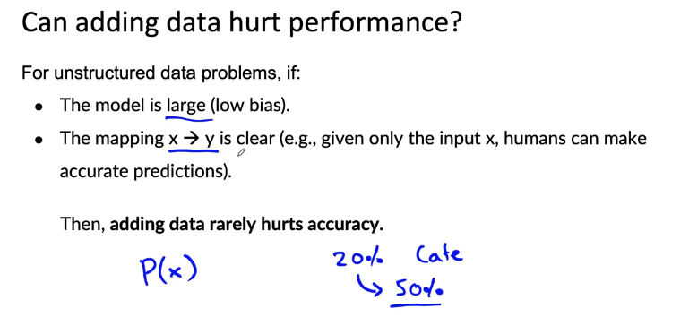

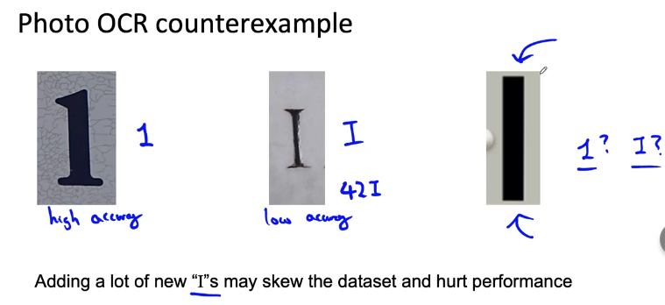

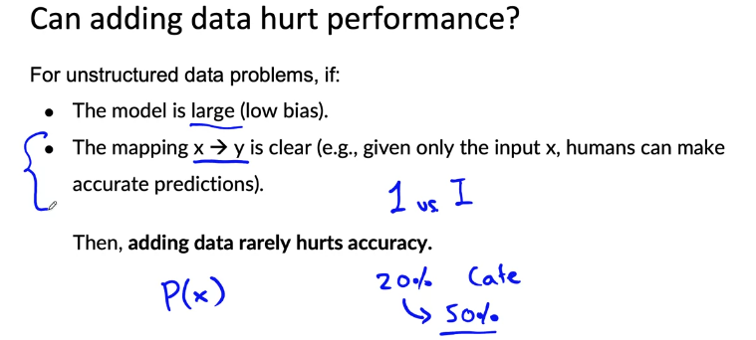
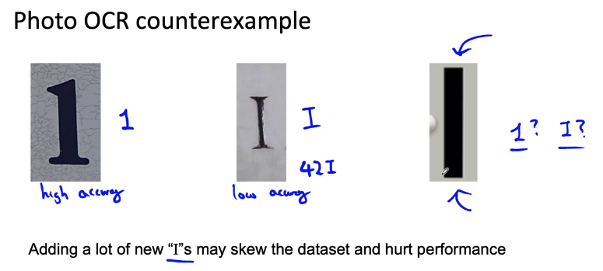

Adding features

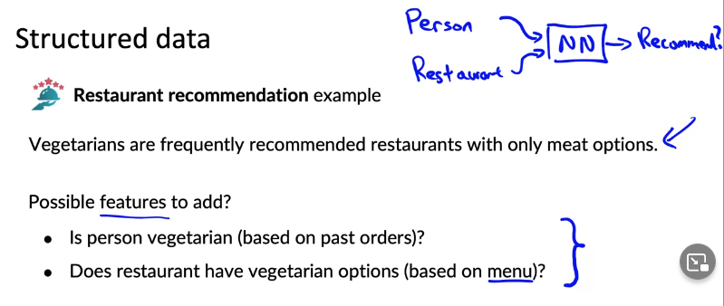

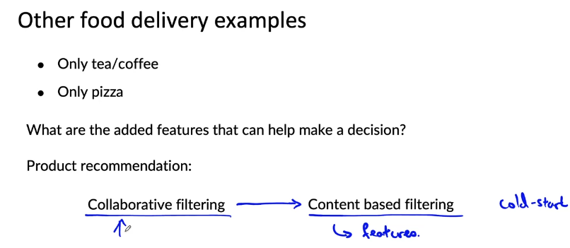
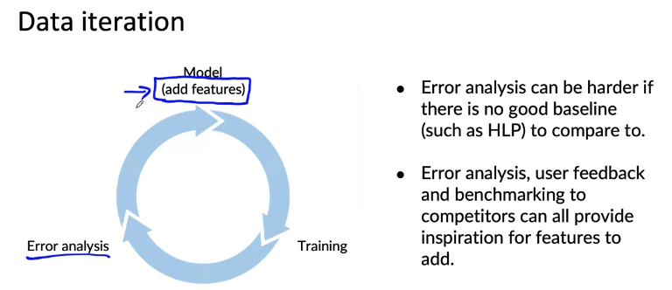

Experiment tracking

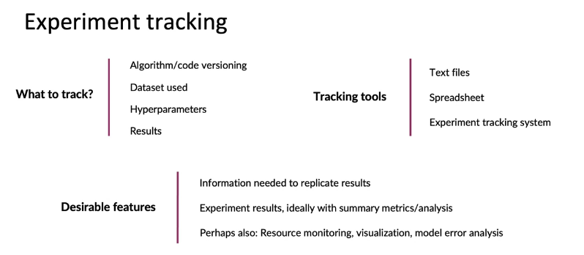

From big data to good data

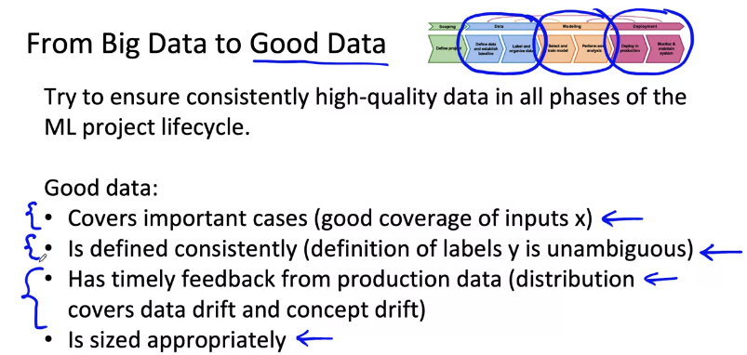

Week-3

Why is data definition hard?
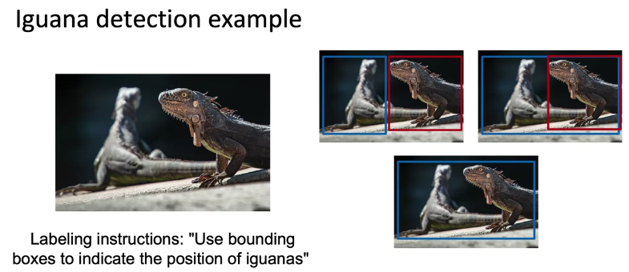



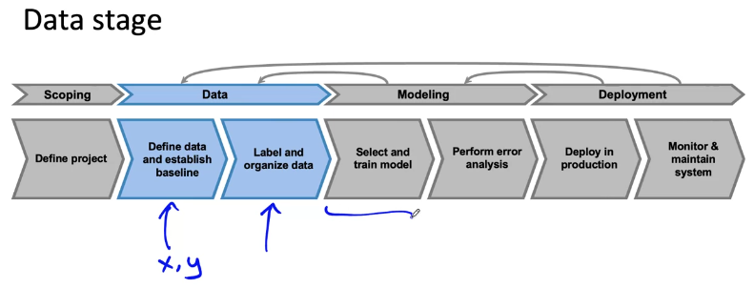

More label ambiguity examples
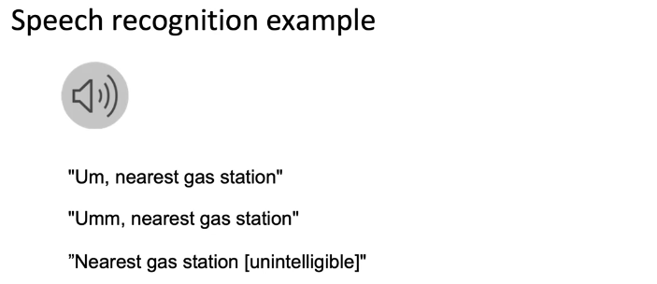

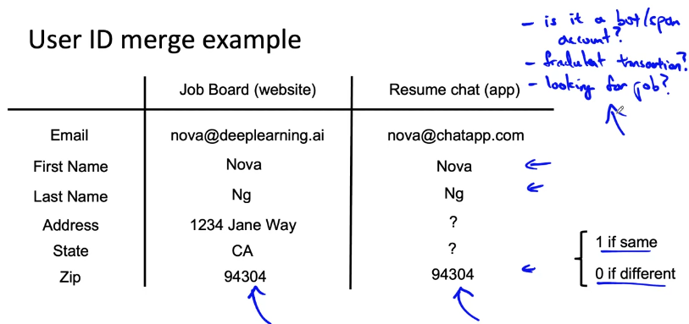
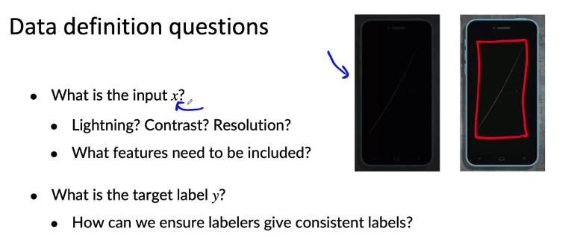

Major types of data problems

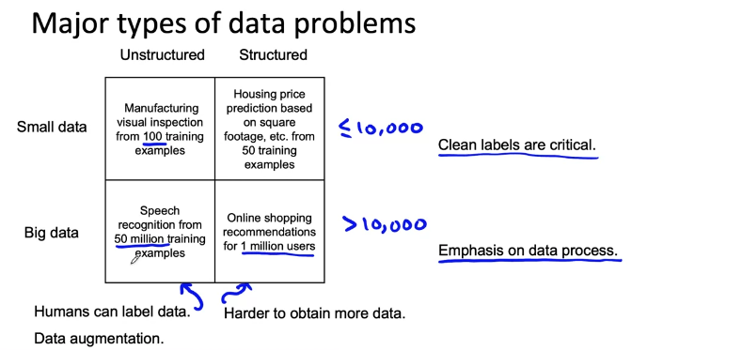

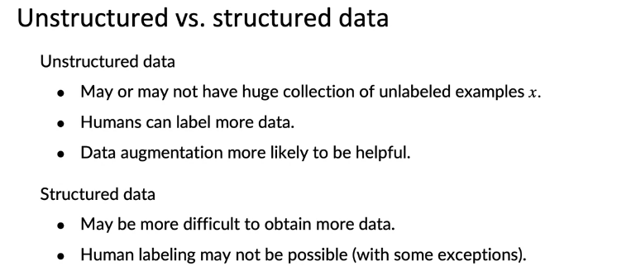

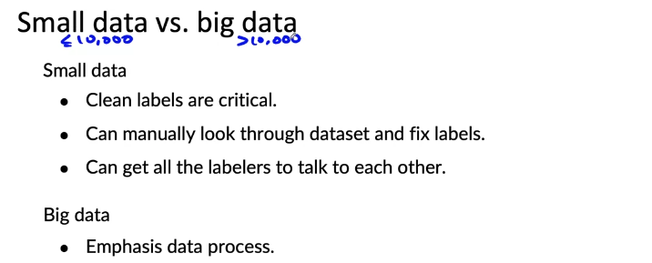

Small data and label consistency

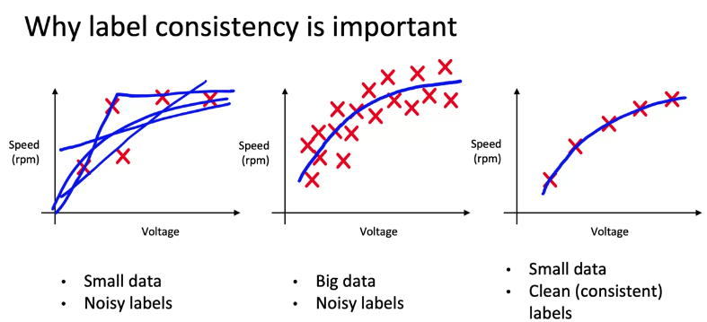

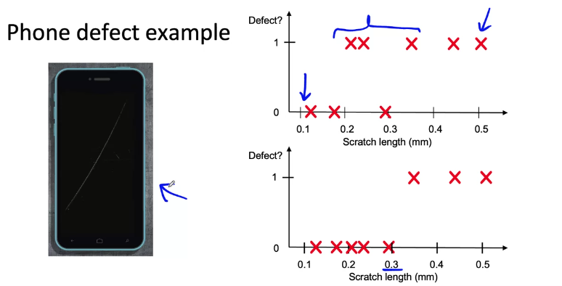
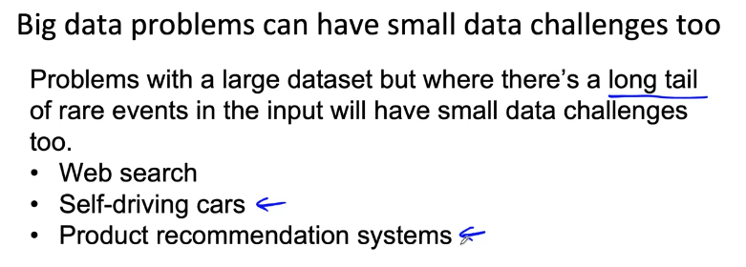

Improving label consistency

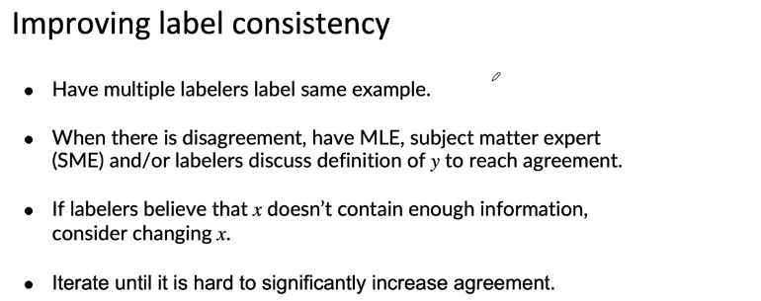
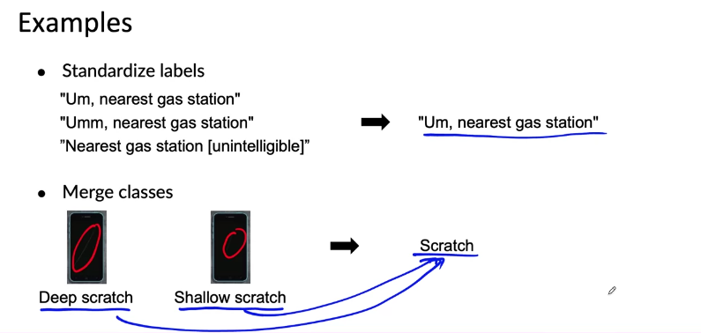

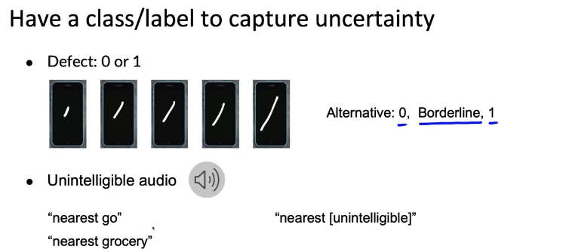
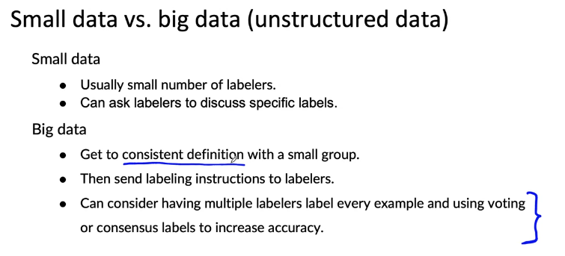

Human level performance (HLP)

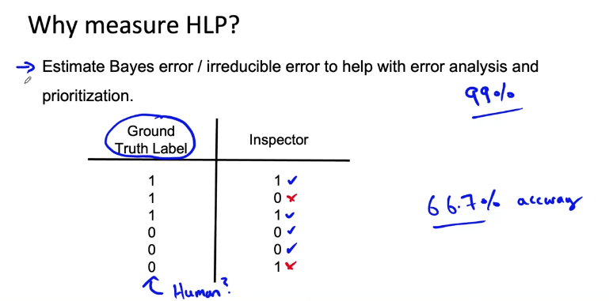
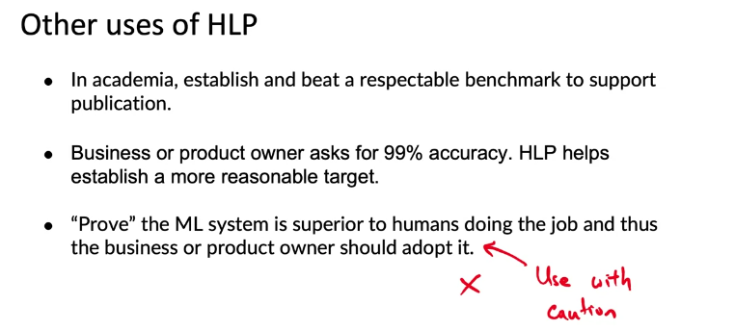

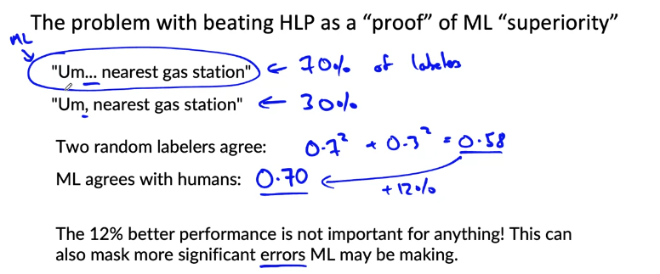

Raising HLP
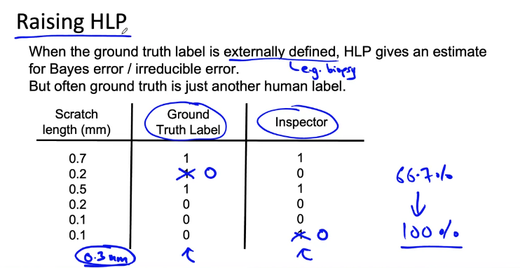

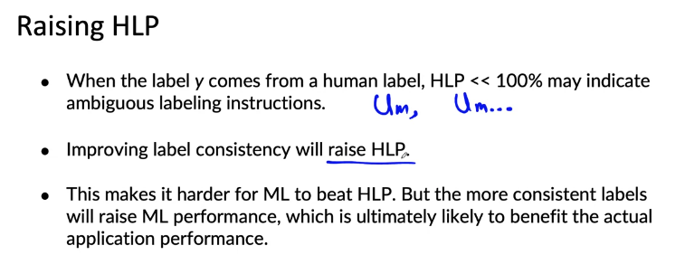
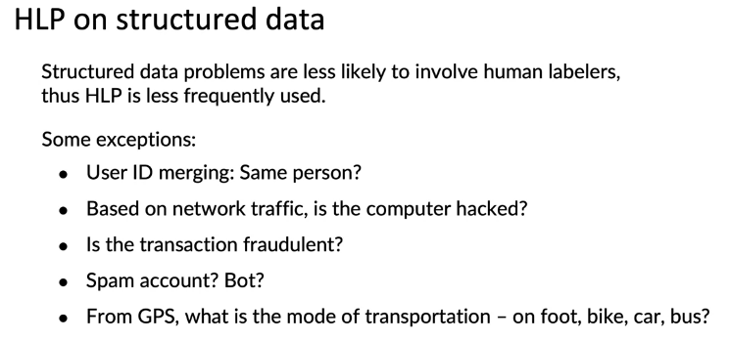

Obtaining data
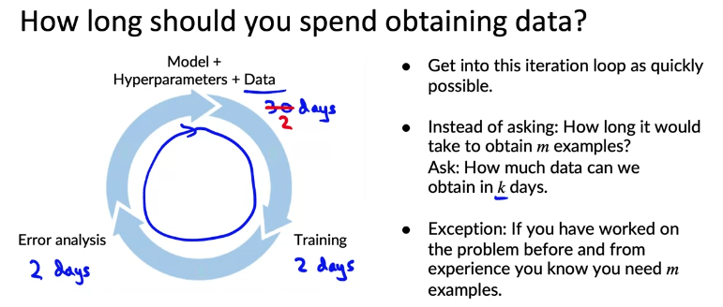
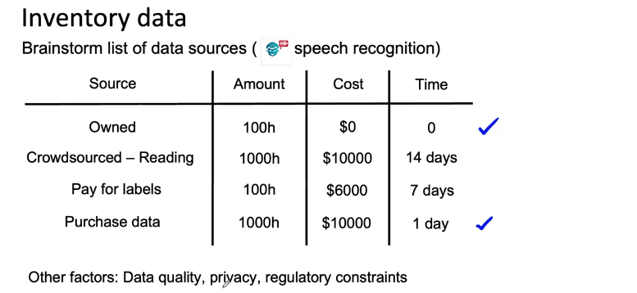
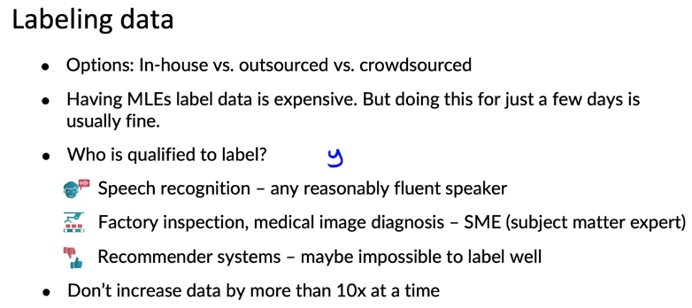

Data pipeline
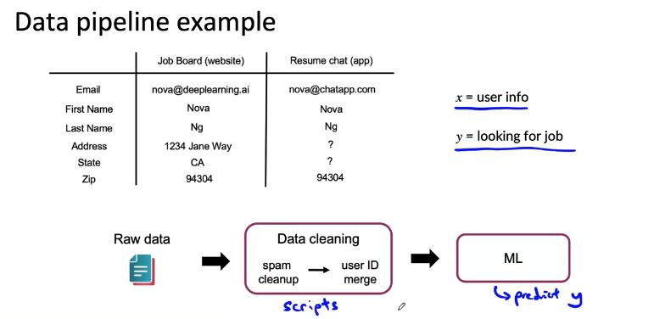
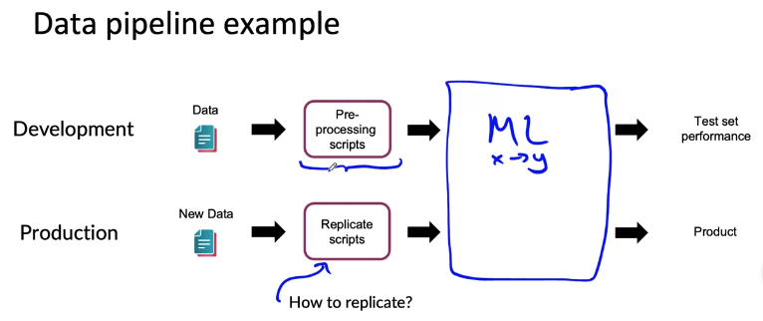
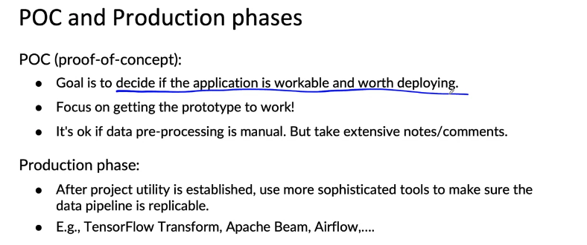

Meta-data, data provenance and lineage
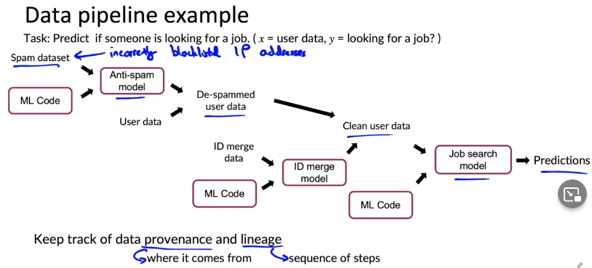

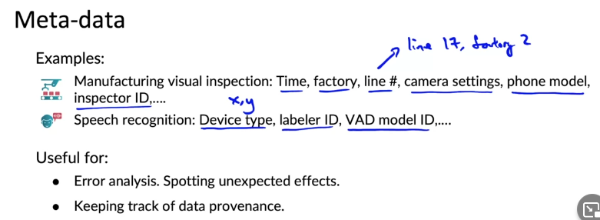

Balanced train/dev/test splits
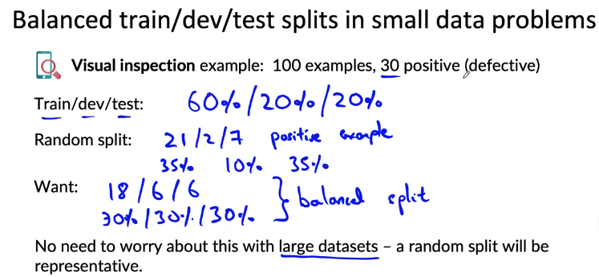

What is scoping?

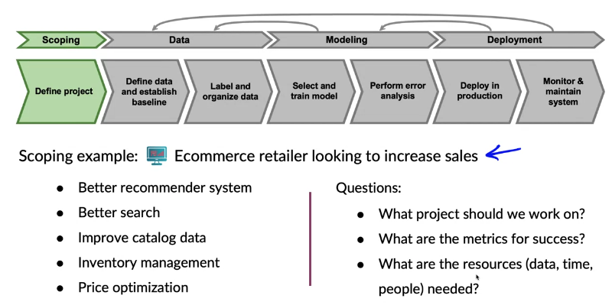

Scoping process
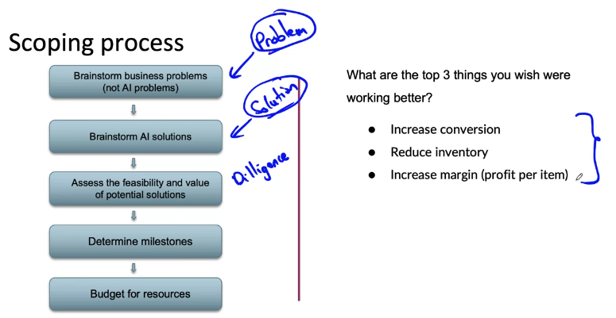

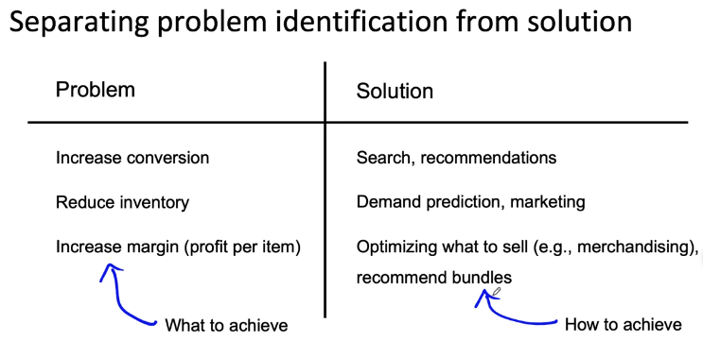

Diligence on feasibility and value

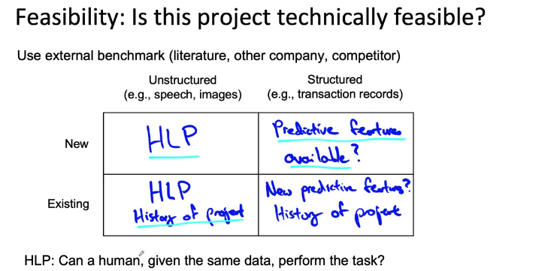
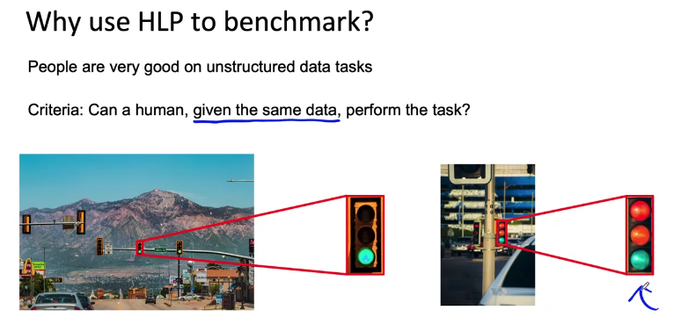
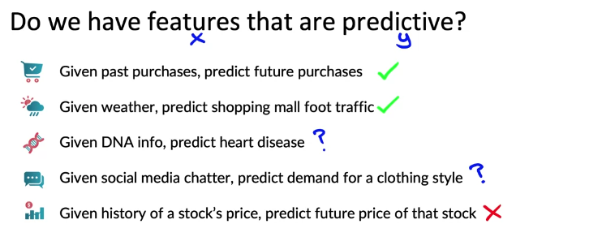
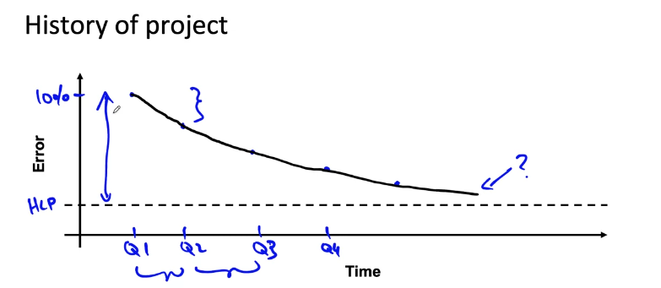

Diligence on value
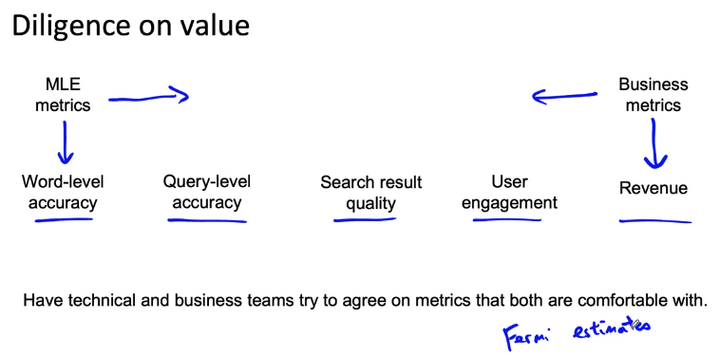

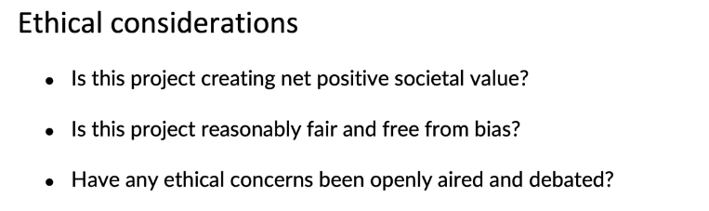

Milestones and resourcing

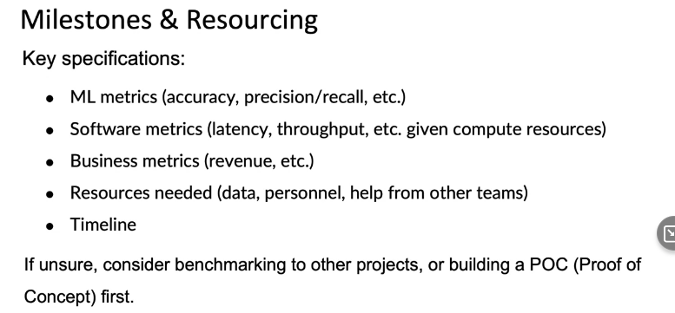

References

Introduction to Machine Learning in Production
This is a compilation of resources including URLs and papers appearing in lecture videos.
Overall resources:
Konstantinos, Katsiapis, Karmarkar, A., Altay, A., Zaks, A., Polyzotis, N., … Li, Z. (2020). Towards ML Engineering: A brief history of TensorFlow Extended (TFX). http://arxiv.org/abs/2010.02013
Paleyes, A., Urma, R.-G., & Lawrence, N. D. (2020). Challenges in deploying machine learning: A survey of case studies. http://arxiv.org/abs/2011.09926

Week 1: Overview of the ML Lifecycle and Deployment
Concept and Data Drift
Monitoring ML Models
A Chat with Andrew on MLOps: From Model-centric to Data-centric AI
Konstantinos, Katsiapis, Karmarkar, A., Altay, A., Zaks, A., Polyzotis, N., … Li, Z. (2020). Towards ML Engineering: A brief history of TensorFlow Extended (TFX). http://arxiv.org/abs/2010.02013
Paleyes, A., Urma, R.-G., & Lawrence, N. D. (2020). Challenges in deploying machine learning: A survey of case studies. http://arxiv.org/abs/2011.09926
Sculley, D., Holt, G., Golovin, D., Davydov, E., & Phillips, T. (n.d.). Hidden technical debt in machine learning systems. Retrieved April 28, 2021, from Nips.cc
https://papers.nips.cc/paper/2015/file/86df7dcfd896fcaf2674f757a2463eba-Paper.pdf

Week 2: Select and Train Model
Establishing a baseline
Error analysis
Experiment tracking
Brundage, M., Avin, S., Wang, J., Belfield, H., Krueger, G., Hadfield, G., … Anderljung, M. (n.d.). Toward trustworthy AI development: Mechanisms for supporting verifiable claims∗. Retrieved May 7, 2021 http://arxiv.org/abs/2004.07213v2
Nakkiran, P., Kaplun, G., Bansal, Y., Yang, T., Barak, B., & Sutskever, I. (2019). Deep double descent: Where bigger models and more data hurt. Retrieved from http://arxiv.org/abs/1912.02292

Week 3: Data Definition and Baseline
Label ambiguity
https://arxiv.org/pdf/1706.06969.pdf
Data pipelines
Data lineage
MLops
Geirhos, R., Janssen, D. H. J., Schutt, H. H., Rauber, J., Bethge, M., & Wichmann, F. A. (n.d.). Comparing deep neural networks against humans: object recognition when the signal gets weaker∗. Retrieved May 7, 2021, from Arxiv.org website:

